

**Panic Disorder Detection**

Final Project Report

Project ID: SWTID1720075414

**1. Introduction**

1.1 Project Overview

The Panic Disorder Detection project aims to develop a machine learning model that can be accessed through a website, enabling individuals to diagnose themselves with panic disorder using multimodal physiological and spatiotemporal data. By analyzing various signals such as heart rate variability, electrodermal activity, and respiratory patterns, the model will provide accurate, real-time detection of panic disorder symptoms. The system will be user-friendly, integrating seamlessly with existing healthcare workflows and electronic health records (EHRs) to offer personalized treatment recommendations and alerts. This innovative solution seeks to improve early detection and management of panic disorder, ultimately enhancing patient outcomes and accessibility to mental health care.

1.2 Objectives

a) Develop a Machine Learning Model:

- Create a robust and accurate machine learning model capable of detecting panic disorder symptoms using physiological and spatiotemporal data.

b) Data Analysis from various databases:

- Implement a system for real-time data collection and analysis to monitor physiological signals and detect panic disorder episodes promptly.

c) Web-Based Diagnostic Tool:

- Develop a user-friendly website that allows individuals to access the machine learning model for self-diagnosis of panic disorder.

d) Data Privacy and Security:

- Implement robust data privacy and security measures to protect user information and ensure compliance with relevant regulations.

e) Continuous Improvement and Feedback:

- Establish mechanisms for continuous feedback from users and healthcare providers to improve the system's accuracy, usability, and effectiveness.

f) Accessibility and Awareness:

- Increase accessibility to mental health care by providing an easy-to-use online tool, and raise awareness about panic disorder and its management.

**2. Project Initialisation and Planning Phase**

2.1 Define Problem Statement

Problem statement : Accurately diagnosing and monitoring panic disorder is challenging due to the reliance on subjective self-reports and clinical interviews, often resulting in misdiagnosis and delayed treatment. There is a critical need for an objective, accurate detection system that utilizes machine learning to analyze physiological and historical data among others, enabling individuals to self-diagnose through a user-friendly website, thereby improving early detection, timely intervention, and overall management of panic disorder.

**Panic Disorder Detection Problem Statement Report:** [LINK](https://github.com/Yagavi8116/Panic-Disorder-Detection/blob/main/1.%20Project%20Initialization%20and%20Planning%20Phase/Define%20Problem%20Statements.pdf)

2.2 Project Proposal

The proposed project, "Panic Disorder Detection" aims to use machine learning for better, more accurate detection of Panic Disorders among individuals. This is done so by using an extensive and comprehensive datset that includes data including past history among individuals, symptoms, cultural and environmental influence, among others. The project aims to make a model that, on the basis of the user input of specific factors, diagnoses the user of panic disorder or otherwise. This initiative enables more efficient, and accurate analysis of panic disorder among individuals.

**Panic Disorder Detection Project Proposal Report:** [LINK](https://github.com/Yagavi8116/Panic-Disorder-Detection/blob/main/1.%20Project%20Initialization%20and%20Planning%20Phase/Project%20Proposal%20(Proposed%20Solution).pdf)

2.3 Initial Project Planning

The initial Project Planning involves collecting a diverse and well balanced dataset from the internet. It then involes going through the dataset and using Python and the various libraries available in python, preparing the datset by performing processes such as oversampling and feature selection. It then moves to figurative analysis of the data to check imbalances, followed by then tuning the data and model building. The model will then be interated with a website, the model running in the background. The decided plan aims to systematically simplify the data obtained from the dataset, makes It digestable for the model to utilize, and the model to then be used for accurate and efficient prediction of Panic Disorder.

**Panic Disorder Detection Project Planning Report:** [LINK](https://github.com/Yagavi8116/Panic-Disorder-Detection/blob/main/1.%20Project%20Initialization%20and%20Planning%20Phase/Initial%20Project%20Planning%20Report.pdf)

**3. Data Collection and Preprocessing Phase**

3.1 Data Collection Plan and Raw Data Sources Identified

The data collected for the purpose of this project was taken from Kaggle. It includes a hefty amount of parameters from symptoms, family history to psychiatric history and stressors that might trigger panice disorder itself. The data itself is verified if it is credible by handling missing and categorical values, and undersampling/oversampling data followed by appropriate feature selection. This ensures that the data is ready for training the chosen model for accurate and proper detection of Panic Disorder.

**Panic Disorder Detection Data Collection Report:** [LINK](https://github.com/Yagavi8116/Panic-Disorder-Detection/blob/main/2.%20Data%20Collection%20and%20Preprocessing/Raw%20Data%20Sources%20And%20Data%20Quality%20Report.pdf)

3.2 Data Quality Report

The data collected for the purpose of this project was taken from Kaggle. It includes a hefty amount of parameters from symptoms, family history to psychiatric history and stressors that might trigger panice disorder itself. The data itself is verified if it is credible by handling missing and categorical values, and undersampling/oversampling data followed by appropriate feature selection. This ensures that the data is ready for training the chosen model for accurate and proper detection of Panic Disorder.

**Panic Disorder Detection Data Quality Report:** [LINK](https://github.com/Yagavi8116/Panic-Disorder-Detection/blob/main/2.%20Data%20Collection%20and%20Preprocessing/Data%20Quality%20Report.pdf)

3.3 Data Exploration and Propressing

Data Exploration involves analyzing the chosen dataset to identify and understand patterns and outliers. Preprocessing includes handling missing values, overscaling/underscaling, among others. These steps enable imporved data quality, improving reliability and efficiency for proper analysis.

**Panic Disorder Detection Data Exploration and Preprocessing Report:** [LINK](https://github.com/Yagavi8116/Panic-Disorder-Detection/blob/main/2.%20Data%20Collection%20and%20Preprocessing/Data%20Exploration%20and%20Preprocessing.pdf)

**4. Model Development Phase**

4.1 Feature Selection Report

A feature selection report for the Panic Disorder Detection project entails a comprehensive analysis of the various physiological and symptom-based features used in the machine learning model to identify which ones contribute to the accurate detection of panic disorder symptoms the most. The report evaluates feature importance using metrics like accuracy, precision, among others, presenting the results from the different methods to highlight which features are most relevant for improving the model's performance in real-time panic disorder detection.

**Panic Disorder Detection Feature Selection Report:** [LINK](https://github.com/Yagavi8116/Panic-Disorder-Detection/blob/main/3.%20Model%20Development%20Phase/Feature%20Selection%20Report.pdf)

4.2 Model Selection Report

The Model Selection Report dives deep into why a specific model, such as Random Forest, or XGboost, or Decision Tree model, has been chosen for the model building. It considers various factors that influence the choosing of a specific model, such as accuracy, importance and efficiency in the ability of the model to correctly and properly decide if an individual has a panic disorder or not.

**Panic Disorder Detection Model Selection Report:** [LINK](https://github.com/Yagavi8116/Panic-Disorder-Detection/blob/main/3.%20Model%20Development%20Phase/Model%20Selection%20Report.pdf)

4.3 Initial Model Training Code, Model Validation, and Evaluation Report

Initial Model Training Code uses specific algorithms on the Panic Disorder dataset, thoroughly training the model with it. The Model Validation assess the final performance of the midel itself by using various metrics like accuracy, F1 Score, among others. The Evaluation Report is the report contains the final statistics obtained at the end of training and validation of the model. Training and Validation is done to make sure the model is reliable and efficient in the prediction of Panic Disorders.

**Panic Disorder Detection Model Development Phase Report:** [LINK](https://github.com/Yagavi8116/Panic-Disorder-Detection/blob/main/3.%20Model%20Development%20Phase/Initial%20Model%20Training%20Code%2C%20Model%20Validation%20and%20Evaluation.pdf)

**5. Model Optimization and Tuning Phase**

5.1 Hyperparameter Tuning Documentation

For the project, the Decision Tree Model was chosen as the final model because of its exceptional accuracy compared to the other models.

5.2 Performance Metrics Comparison Report

The Performance Metrics Comparison Report conatains the results provided by all the trained models, highlighting the imporved performance of all the models done by Hyperparameter Tuning. By looking at the results, Decision Tree was found to have the highest amount of accuracy and efficiency. Hence, this assessment has provided a proper and clear understanding of the various results that were been provided by the models by hyperparameter tuning, and enabled us to choose the best.

5.3 Final Model Selection Justification

The Final Model Selection Justification contains the various reasons for choosing the model, in this case being the Decision Tree Model, as the final model. In our case it was the exceptional accuracy and efficiency with which the output was provided by the model that convinced us to move ahead with this model for the project.

**Panic Disorder Detection Model Optimization and Tuning Phase:** [LINK](https://github.com/Yagavi8116/Panic-Disorder-Detection/blob/main/4.%20Model%20Optimization%20and%20Tuning%20Phase/Model%20Optimization%20and%20Tuning%20Phase%20Template.pdf)

**6. Results**

6.1 Output Screenshots

a) index.html

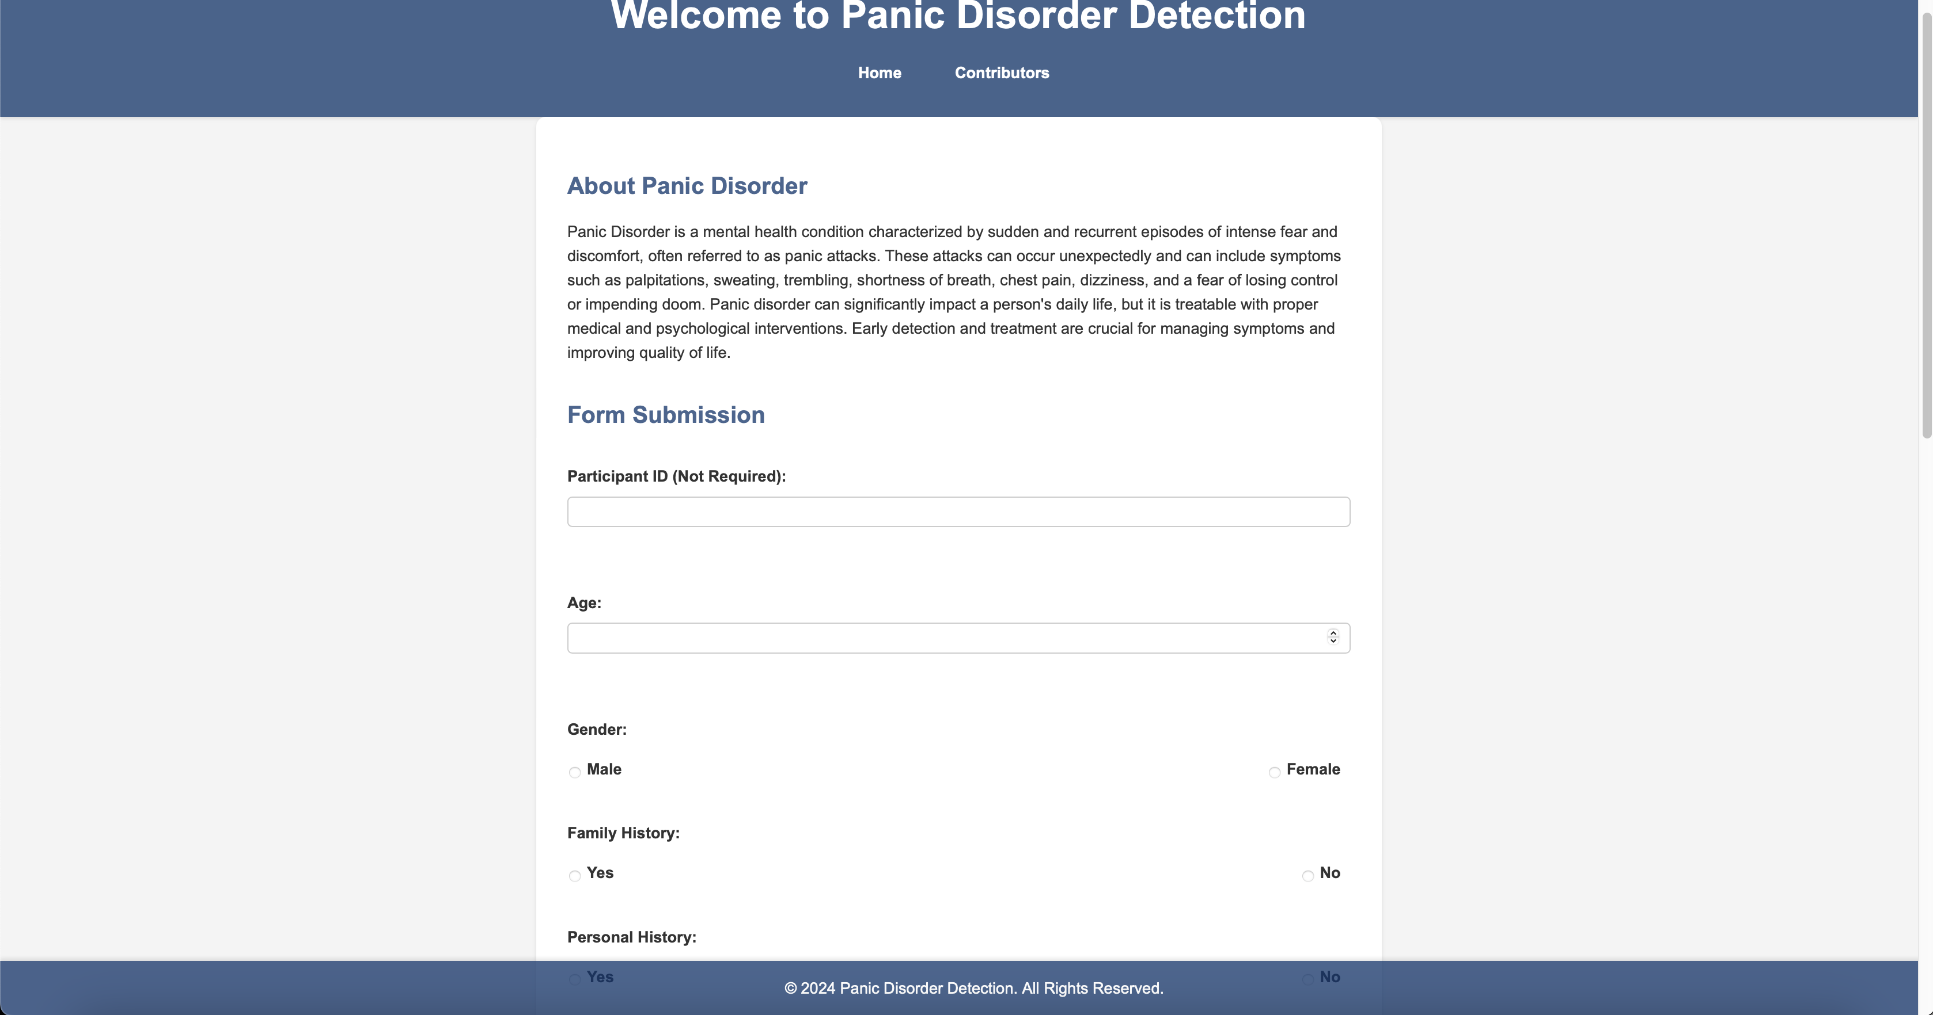

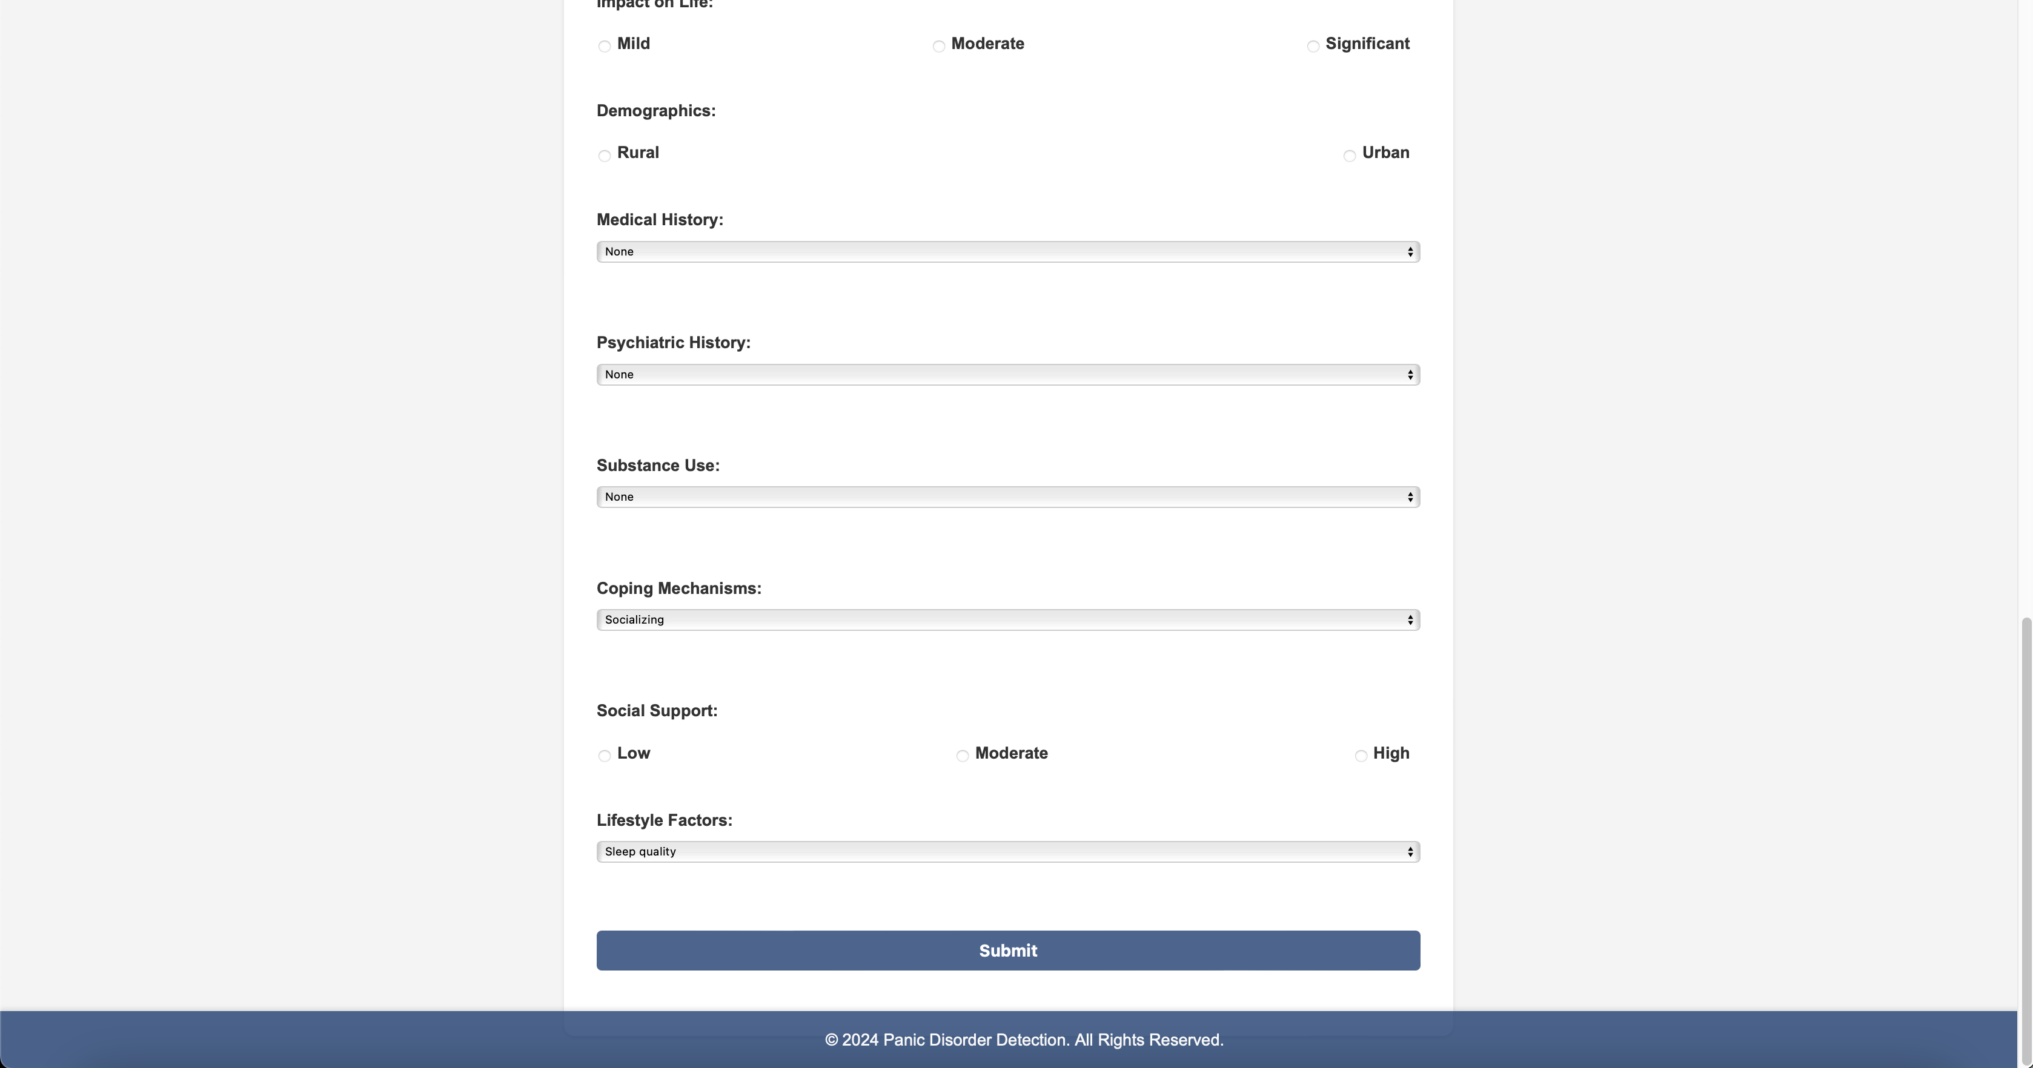

b)contributors.html

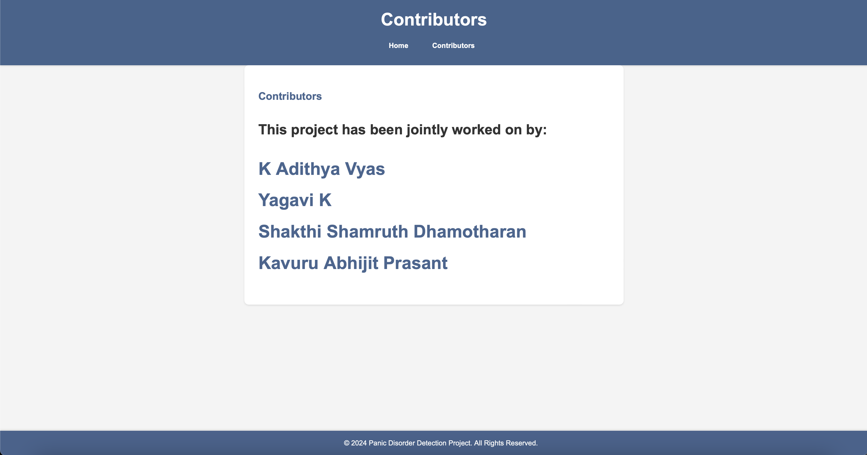

c) Case 1: User is Normal

**Input:**

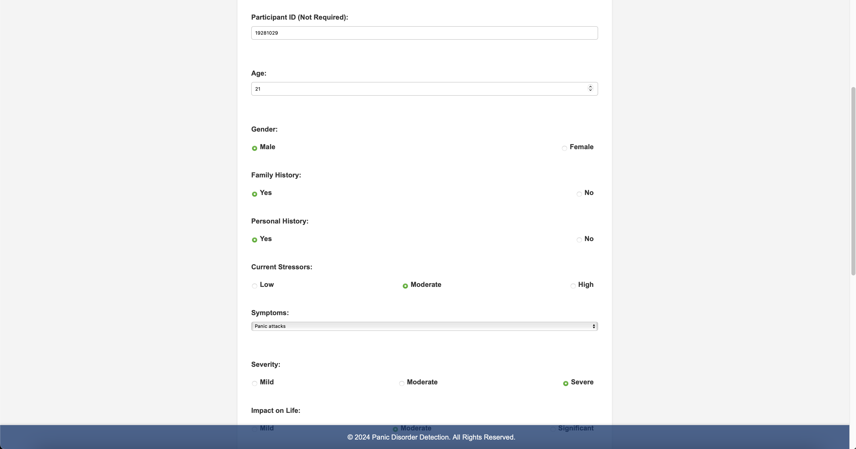

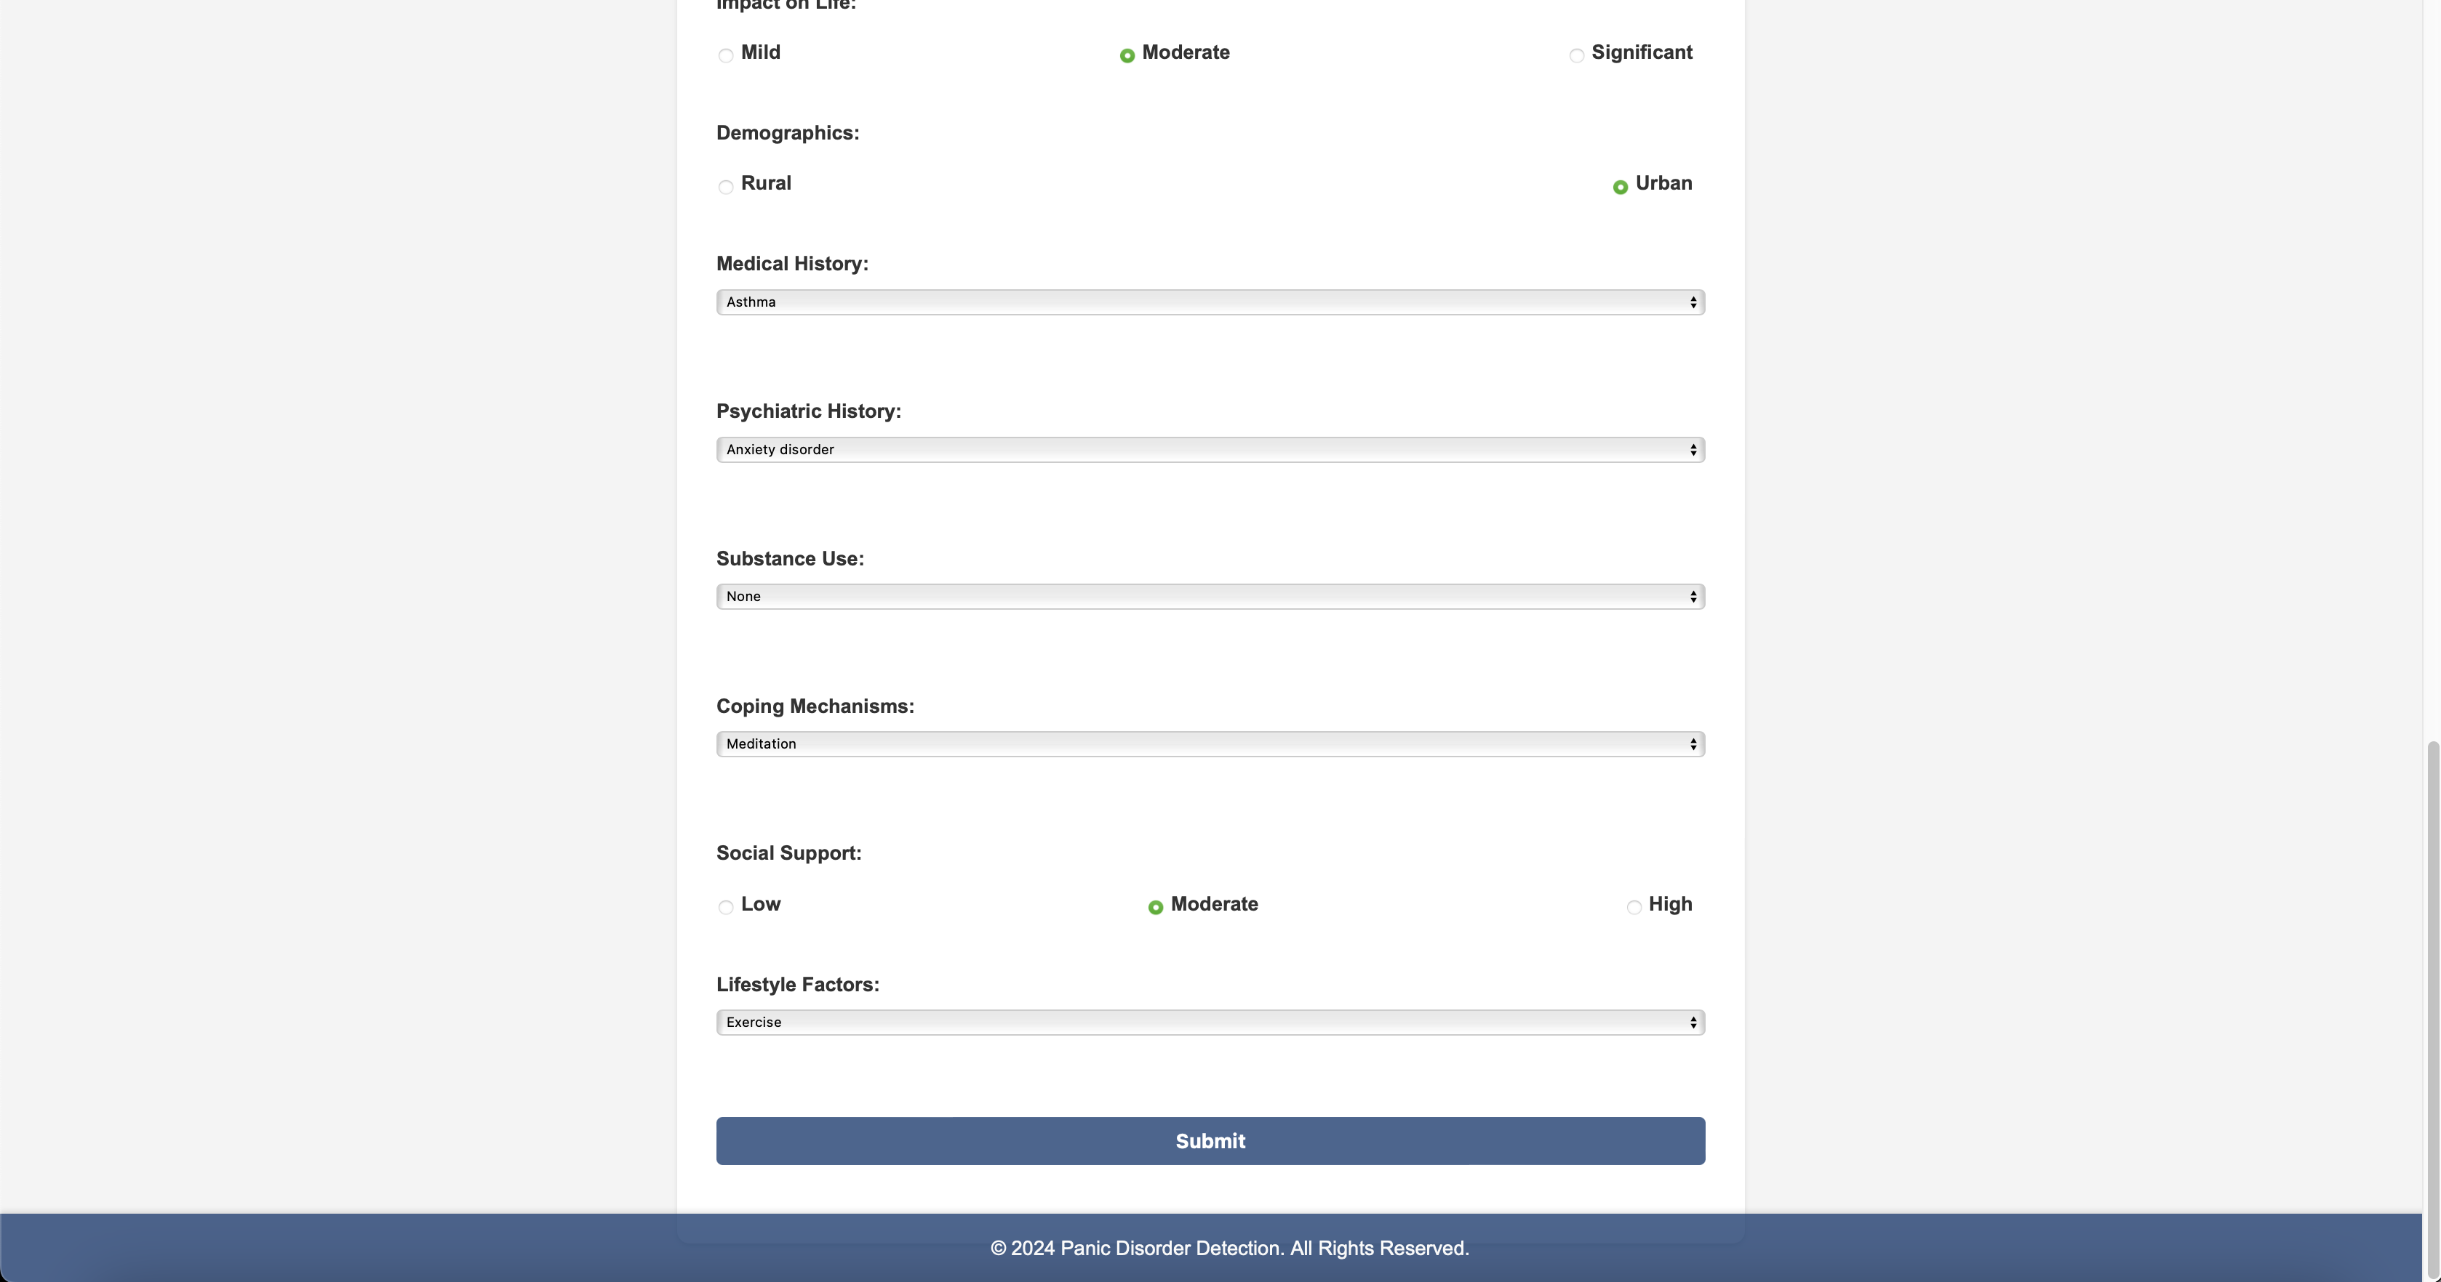

**Output:**

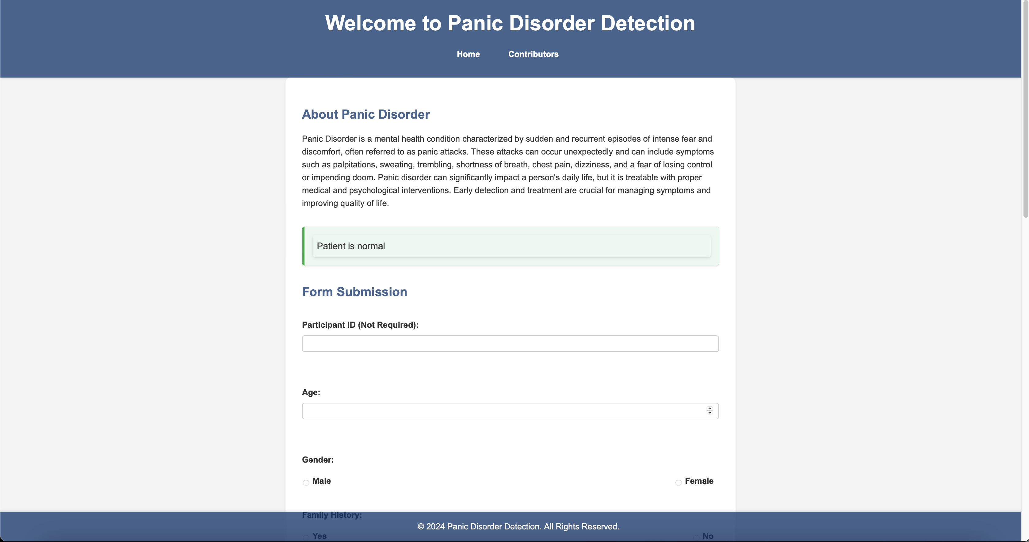

d) Output 2: Patient might face panic disorder

**Input:**

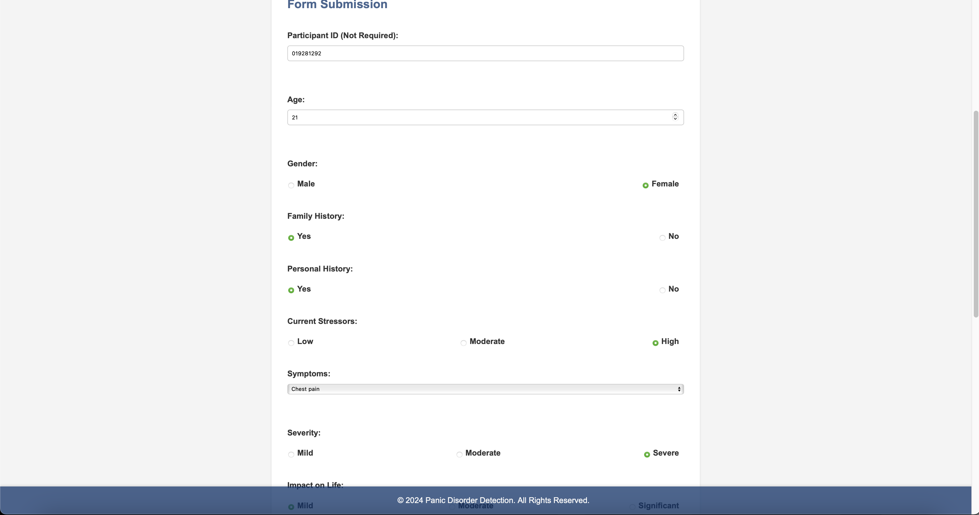

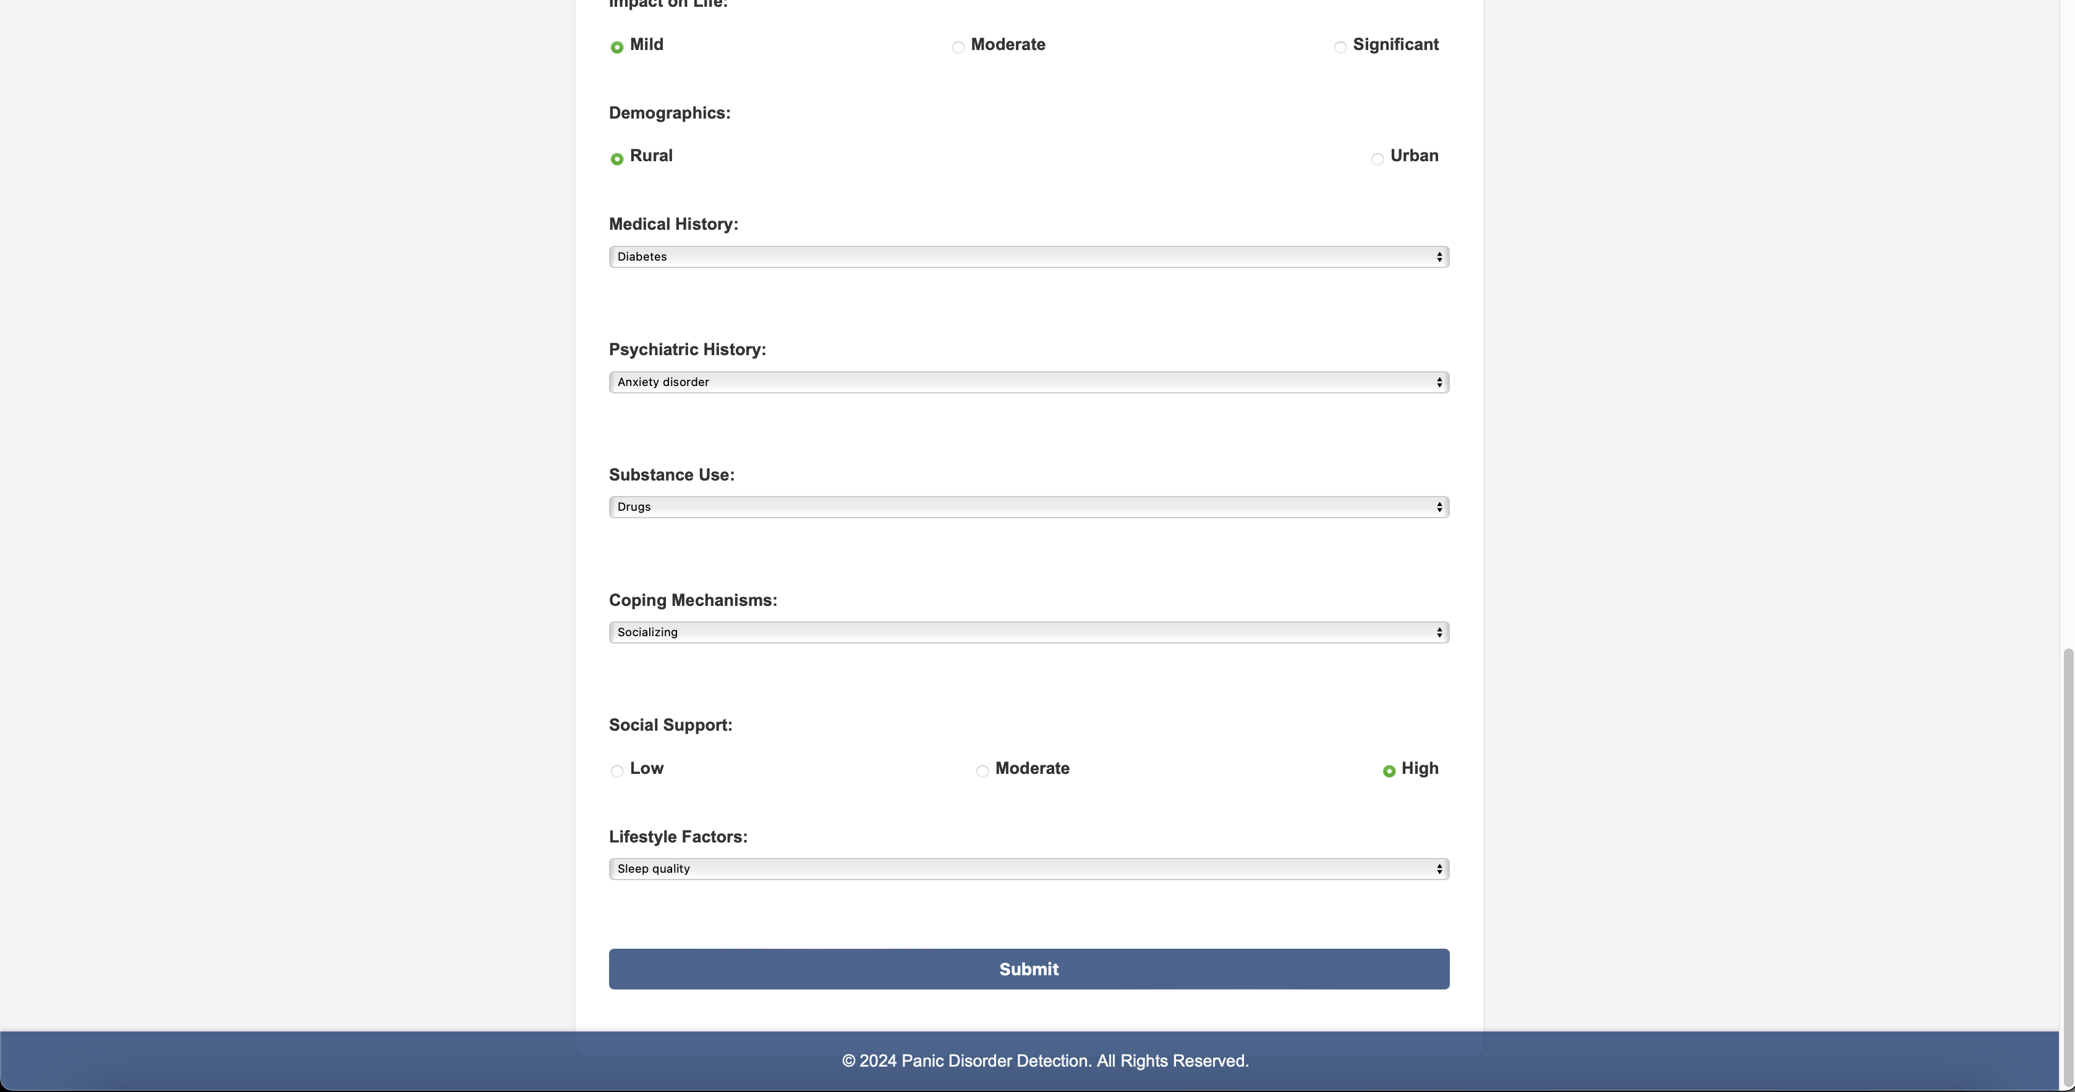

**Output:**

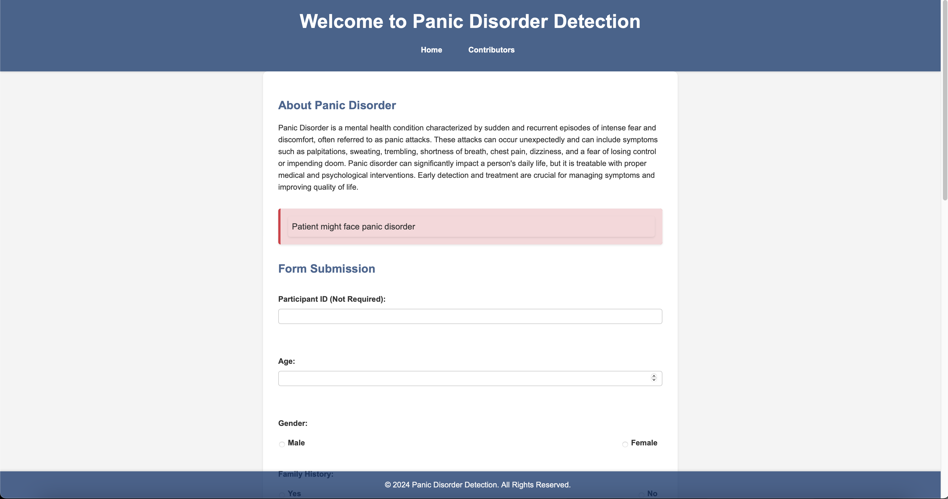

**7. Advantages and Disadvantages**

Using models for the detection of panic disorder on a website has various benefits. They are accessible, allowing people to diagnose themselves from the comfort of their own homes. This is especially helpful for people who do not have easy access to mental health care. The ability to act promptly is made possible by proper diagnosis. Furthermore, the incorporation of both physiological and spatiotemporal data improves detection accuracy and provides a more thorough and objective evaluation than conventional techniques that rely on self-reports. In order to maintain the model's effectiveness and relevance, the online platform also enables ongoing modifications and changes based on user feedback and fresh study findings. Additionally, these models help lessen the stigma attached to panic disorders and increase awareness of them by offering an easily accessible tool for mental health care.

Nevertheless, there are drawbacks to utilizing models for the detection of panic disorder on a website. Because sensitive physiological and location data collection and analysis have to conform to strict guidelines and protect user information, privacy and security considerations are of utmost importance. The digital divide may get wider if people who lack access to these resources are left behind due to the dependence on internet connectivity and digital literacy. Additionally, there's a chance of false positives or negatives, which could lead to unneeded worry or a delusion of security, respectively. Lastly, even though the model can help with detection, it cannot replace professional diagnosis and treatment, underscoring the importance of integrating such tools within broader healthcare support systems.

**8. Conclusion**

To sum up, the Panic Disorder Detection project offers a user-friendly web-based platform that allows people to diagnose panic disorder based on their input, which is an important advance in mental health self-assessment tools. Through the use of machine learning to evaluate data submitted by users, this research helps identify possible panic disorder symptoms early on. It aims to enable people to better understand their mental health state and seek appropriate professional care when needed, with a focus on accuracy and convenience of use. In the future, encouraging proactive mental health management in the community will depend on improving user education on mental health and making sure such tools are accessible.

**9. Future Scope**

The Panic Disorder Detection project's future goals include improving machine learning models' accuracy and validation using a variety of datasets. In order to present a thorough picture of the patterns and triggers related to mental health. This involves including further behavioral data. Users will be helped in efficiently managing their condition through the development of customized materials and systems for personalized feedback. Over time, the platform might grow to include self-care tools, instructional resources, and symptom monitoring features. Global accessibility initiatives will cater to a range of cultural and linguistic needs, while collaboration with healthcare providers will guarantee a smooth formation into clinical operations. The integration of the most recent developments in mental health diagnostics will be driven by ongoing research and innovation, positioning the project to continuously improve and expand its influence on mental health awareness and support.

**10. Appendix**

10.1 Source Code

10.2 Github and Project Demo Link